**Exploring Student Engagement through Social Learning Analytics:**

**A Network Analysis of Asynchronous Discussions**

**Minkyung Lee1, Priya Sharma2**

**1,2 Department of Learning and Performance Systems, Pennsylvania State University**

**Abstract**

Asynchronous discussions have become a vital component of digital learning, offering flexibility but also presenting challenges in student engagement and participation. This study explores the network dynamics of Asynchronous discussions to understand why certain students receive more responses than others, using Social Learning Analytics with a specific focus on network analysis. Data was drawn from a series of online business course modules, examining the interaction patterns of 38 students using key centrality measures, including indegree, outdegree, eigenvector, betweenness, and closeness centralities. ANOVA revealed significant differences between high- and low-response-receiving students, particularly in indegree and eigenvector centralities. A multiple regression analysis demonstrated that while high indegree and eigenvector scores correlate positively with engagement, a higher outdegree does not necessarily lead to more responses, suggesting a focus on quantity over quality may hinder peer engagement. Ego network analysis further highlighted how central figures in discussions amplify engagement by bridging connections with less active participants. These findings suggest that fostering meaningful engagement requires attention to not only the quantity, but the quality of contributions and the roles students play in the network. Implications for educators and platform designers are discussed, including how network metrics can be leveraged to create more inclusive and dynamic online learning environments. Limitations of the study and directions for future research are also presented, including the need for discourse analysis to better understand qualitative factors influencing engagement.

Keywords: asynchronous discussions, Social Learning Analytics, network analysis, student engagement, centrality measures, online learning

**Introduction**

The evolution of learning analytics offers robust tools and methodologies to analyze and interpret extensive student data, which is especially compelling in online environments where every interaction, post, and response can be captured and analyzed in the context of learning outcomes (Siemens, 2013). The ability to understand online discussions has become central to this analytical evolution. asynchronous discussions, a significant component of many Learning Management Systems (LMS), provide a flexible platform for student interactions, transcending the limitations of time and geographical constraints (Hrastinski, 2008). However, while the asynchronous format offers flexibility, it also introduces distinct challenges. One of these challenges is the potential for diminished social presence and inherent delays in receiving feedback (Borup et al., 2012; Dennen, 2008; Kovanović et al., 2015). Beyond these issues, the dynamics of asynchronous discussions are influenced by various factors. For instance, the quality and timing of a post can significantly shape the level of engagement it receives (Wise & Cui, 2018; Koh et al., 2010; Gao et al., 2013). Additionally, the role of the instructor and the nature of discussion prompts can significantly impact either catalyzing or stifling student interactions (Dennen, 2008; Xie & Correia, 2023).

Despite these insights, there remains a gap in the literature regarding the intricate network dynamics inherent to asynchronous discussion, particularly concerning the disparities in response rates among students. To bridge this gap, this study utilizes the concept of Social Learning Analytics (SLA). While traditional methods of gauging engagement often relied on self-reported scales, interviews, or teacher observations, SLA provides a behavior-based ubiquitous method to extract engagement features. This method can be pivotal in predicting dropout rates, flagging students at risk, and enabling timely interventions by educators (Dixson, 2015; Saqr & Lopez-Pernas, 2021). SLA includes various types of analyses—network analysis, discourse analysis, content analysis, disposition analysis, and context analysis (Ferguson & Shum, 2012). However, not all these types of analytics need to be applied in any given study. Researchers can tailor their approach based on the available data and the focus of their research.

For this study, the focus is on network analysis within SLA. Network analysis offers a powerful lens through which to examine the relational and interactional dynamics between students. Drawing inspiration from past research (Wise et al., 2014; Wise & Cui, 2018), this study utilizes anonymized interaction data from a business course module’s forum. Through post-hoc analysis rooted in learning analytics, we aim to uncover intricate patterns of online student engagement, shedding light on the nuances of interaction dynamics and network structures (Dawson, 2008). By leveraging social network analysis, this research explores how students connect with one another, the role of certain individuals as central figures in discussions, and how these connections influence engagement. Centrality measures, such as indegree, outdegree, betweenness, and eigenvector centrality, are pivotal in identifying patterns of student interaction and influence (Saqr et al., 2020a).

This approach aligns with the extracted analytics perspective, which focuses on analyzing interaction data after the activity has taken place. Extracted analytics, as noted by Wise et al. (2014), provide valuable insights into student engagement by examining digital traces post-activity. These insights offer practical applications for improving the design of asynchronous discussions, fostering more balanced and inclusive interactions.

By utilizing SLA’s network analysis, this study captures the social dynamics in asynchronous discussions, addressing gaps in understanding why certain students receive more responses than others. This research explores the network dynamics in asynchronous discussions to elucidate factors influencing response rates and unravel the complexities of student interactions within these forums. The insights derived from this research will offer practical, actionable knowledge to enhance engagement and interaction in asynchronous discussions, fostering more effective, inclusive, and balanced educational discussions.

**Literature review**

**Social Learning Analytics (SLA)**

Social Learning Analytics (SLA) offers a powerful approach to understanding learning processes in collaborative environments, particularly by analyzing interactions and behaviors within digital networks. SLA focuses on the social dimension of learning, using digital traces from student activities to identify patterns of participation, collaboration, and engagement that influence learning outcomes (De Laat & Prinsen, 2014; Shum & Ferguson, 2012). This approach is particularly useful in higher education, where social learning environments such as online discussions and MOOCs are becoming increasingly important.

SLA differs from traditional learning analytics by placing emphasis on the collective nature of learning, rather than solely on individual performance. Through network analysis techniques, SLA can reveal how students build connections, contribute to knowledge construction, and engage in communities of practice (Kaliisa et al., 2022). In these environments, students’ social roles and their positioning within the network can have significant effects on their learning experiences and the outcomes of their peers. Studies that apply SLA, such as De Laat & Prinsen (2014), highlight the utility of these tools in raising awareness about students’ social mobility and helping them make informed decisions about where to participate and whom to collaborate with.

Recent work, including the systematic review by Kaliisa et al. (2022), identifies key trends in SLA research, particularly its application in formal online learning settings. This review of 36 studies between 2011 and 2020 shows that SLA is predominantly used to understand students’ collaborative learning behaviors through methods like social network analysis (SNA) and discourse analysis. However, the review also highlights gaps, such as the need for more sophisticated analytical techniques that integrate multiple methods, including epistemic network analysis and multimodal network analysis. These newer techniques allow for deeper insights into how knowledge and relationships evolve over time in collaborative learning environments. Furthermore, they underscore that while SLA research has focused on understanding student interactions, there is still limited use of these insights to support teaching practices. Few studies have shared SLA results with educators in ways that help inform instructional design or classroom interventions. This is an area where SLA can grow, particularly by developing tools that provide real-time feedback to teachers, enabling them to tailor their instructional strategies to promote more equitable participation and collaboration.

In this study, SLA's inherent social dimension, particularly through network analysis, is crucial in understanding why some students receive more responses than others. The indegree centrality we measure directly correlates with students' influence and popularity in these online discussions, making SLA particularly suited to the analysis of response patterns. The use of SNA to analyze relationships between participants offers a powerful lens to investigate social learning processes, where those with higher centrality often play key roles in shaping the group’s discourse and knowledge construction (Carvalho et al., 2016; Kaliisa et al., 2022).

The focus on SLA also aligns with the evolving pedagogical trends in higher education, where collaborative and participatory learning models are becoming more prominent. SLA supports this shift by providing the tools to map out social connections and collaborative patterns in digital learning environments. These insights are particularly valuable in asynchronous online discussions, as they help to highlight the social structures and dynamics that can either facilitate or inhibit productive learning interactions.

**Network Analysis in Education**

While **Social Network Analysis (SNA)** has long been utilized in fields such as sociology and business, its application in educational research has seen more recent growth, particularly in online learning environments. Scholars like **Haythornthwaite (2000)** and **Palonen & Hakkarainen (2000)** were among the first to apply SNA in educational settings, recognizing its value for understanding relationships among students in digital learning platforms. These early studies revealed that SNA provides novel insights into interaction patterns and social structures that are otherwise difficult to capture using traditional observational methods (Russo & Koesten, 2005).

In educational contexts, **centrality measures** such as **indegree, outdegree, betweenness**, and **eigenvector** are critical for understanding the prominence and influence of specific students within a network. These measures help to dissect how certain students become focal points, thus receiving more responses and consequently exerting more influence within online learning environments. For instance, Saqr & Lopez-Pernas (2022) explored the use of centrality measures from SNA in collaborative learning settings. The study concludes that degree and eigenvector centrality measures can serve as reliable predictors of student success in collaborative learning settings. However, short-path centralities (closeness and betweenness) were less consistent and should be used cautiously. Another study by Saqr et al.(2022) conducted a systematic review and meta-analysis of 19 studies exploring the utility of SNA in assessing students' interactions in **Computer-Supported Collaborative Learning (CSCL)** environments, identifying centrality measures as strong indicators of achievement. Notably, **degree centralities** consistently showed the strongest correlation with final course grades, while **eigenvector centralities** also demonstrated positive and significant correlations across the studies.

**Indegree centrality** focuses on the number of incoming links a student has, which translates to the number of responses a student receives in online forums. Several studies have shown that high indegree centrality often correlates with perceived popularity or authority and prestige (Baldwin et al., 1997; Galikyan & Admiraal, 2019; Vlachopoulos, P., 2012) Students with high indegree centrality are often those who demonstrate subject matter expertise or take on mentoring roles within the forum, becoming central figures around whom discussions gravitate. **Outdegree centrality** considers the number of outgoing links a student initiates by interacting with others. This measure highlights active participants who contribute to various discussions, often driving the conversation and encouraging others to respond. Such students are crucial for sustaining dialogue and engagement within collaborative environments (Wise et al., 2013). **Betweenness centrality** measures the extent to which a student acts as a bridge between other students in the network. Students with high betweenness centrality play a key role in connecting disparate discussion threads or groups. These "bridge builders" may not be the most active contributors, but they are pivotal in enriching dialogue and creating a cohesive learning community. They help ensure that knowledge and ideas are disseminated across different clusters of students (Saqr et al., 2020b). **Eigenvector centrality** builds on indegree by not only counting the number of connections a student has but also considering the influence of those connections. Students with high eigenvector scores are connected to other highly central individuals, which can signify a "rich club" phenomenon (Saqr et al., 2020b). This suggests that influential students are more likely to engage with other key players, thus reinforcing their central position within the network (De Laat, 2012). In educational settings, this could mean that students who interact with influential peers are more likely to become influential themselves.

Another important concept in network analysis is the **clustering coefficient**, which indicates the density of a student's ego network—how interconnected a student’s peers are. A high clustering coefficient suggests that a student’s contacts are well-connected to each other, leading to a tightly-knit community (Saqr et al., 2020b). Ego networks, which focus on the individual at the center of their network and their direct relationships, help map the key actors in a student's learning environment. These ego networks consist of an ego (the individual), alters (contacts), and the ties representing their relationships (Borgatti, 1998).

Network analysis has become an invaluable method for examining how students engage in collaborative learning, particularly in **online and blended learning environments.** In such settings, social network analysis helps researchers track the development of social relationships and the formation of learning communities (Kaliisa et al., 2022). Studies utilizing network analysis consistently find that students with high centrality scores—especially high indegree and betweenness—often play crucial roles in group dynamics. They facilitate the flow of information, encourage collaboration, and act as knowledge brokers. For example, **Bakharia & Dawson (2011)** used SNA to investigate student engagement in online discussion forums, identifying students with high centrality measures as critical figures in fostering collaboration. These students served as hubs, connecting more peripheral participants to the larger group and ensuring that discussions remained dynamic and inclusive. Similarly, **Haythornthwaite and De Laat (2010)** demonstrated that students with high centrality are more likely to help others integrate into the learning community, making them essential for promoting group cohesion and knowledge sharing. It, especially through centrality measures, offers educators a detailed lens to understand how students interact, influence one another, and contribute to the learning process. By identifying central students and their roles, educational practitioners can design interventions to support more balanced and inclusive participation, enhancing the overall collaborative learning experience.

**Asynchronous discussion and factors influencing response rates**

Asynchronous discussions have become a vital component of many Learning Management Systems (LMS), fostering interaction among students without the constraints of time and place. These platforms provide flexibility, allowing students to engage in more thoughtful and reflective participation (Hrastinski, 2008). While much of the existing research has focused on enhancing learner engagement or deepening cognitive engagement, there is limited exploration into why certain contributions receive more responses than others, an area that warrants further investigation.

Post quality is a key determinant of response rates in asynchronous discussions. Posts that are well-structured, coherent, and intellectually stimulating are far more likely to attract responses. According to Hew & Cheung (2011), contributions that invite further exploration or challenge existing viewpoints tend to generate higher levels of engagement. Conversely, posts that lack depth or simply reiterate previous comments may stifle interaction and reduce the likelihood of receiving additional responses. Gao et al. (2013) further support this, noting that posts introducing fresh perspectives or posing thought-provoking questions are more likely to create meaningful exchanges, which in turn leads to higher response rates.

In further support of the importance of content-driven engagement, Wise and Cui's (2018) study on participation in Massive Open Online Courses (MOOCs) highlights the relationship between forum contributions and learning outcomes. Their findings show that students who actively engage in content-related discussions are more likely to succeed in the course compared to non-contributors, suggesting that content quality and relevance are crucial to meaningful participation. However, they also found that the quantity of posts related to course content slightly predicted higher grades, while measures of social network centrality—indicative of students' connectedness in discussions—did not add predictive value beyond the number of posts. This reinforces the argument that the substance of contributions, particularly those related to the course material, is more influential in determining engagement and outcomes than mere social presence or centrality within a network.

While the timing of posts may contribute to their visibility, the relationship between timing and response rates is less straightforward. Early posts may have the advantage of longer exposure, but Dringus and Ellis (2010) found that discussions often experience peaks and declines in activity, and late contributions—particularly those posted outside peak periods—are less likely to generate responses. However, this temporal aspect is only one part of the equation, and it is the quality of the content that remains the primary driver of engagement. Posts that engage participants with thoughtful insights or challenging perspectives are more likely to sustain ongoing discussion, regardless of when they are posted.

The role of the instructor and the design of discussion prompts also contribute to the dynamics. Instructors can stimulate discussions by offering insightful contributions or posing follow-up questions, but their participation must be carefully balanced. As highlighted by Xie and Correia (2024), while instructor presence and frequency can positively affect the quantity and quality of student participation, excessive involvement may shift the focus from peer-to-peer interaction to an instructor-centered discussion (Boling et al., 2012).Well-crafted discussion prompts that encourage students to connect with the material and each other, combined with appropriately timed instructor input, can lead to richer, more engaged conversations.

Moreover, the design of the technological platform used for discussions can affect student interaction. Platforms that provide intuitive navigation and notifications for new posts enhance participation by keeping students informed and prompting timely responses (Gros & García-Peñalvo, 2023; Rose & Ferschke, 2016). This helps maintain a continuous flow of communication, ensuring that posts are not overlooked due to design limitations or lack of notification.

Despite a range of studies exploring how to increase engagement or deepen cognitive participation, there remains a gap in understanding the network structures that underlie response rates in asynchronous discussions. Specifically, why some students consistently receive more responses than others, or why certain posts attract a disproportionately high number of replies, is not fully explained in the literature. By employing a network analytical approach, the current study seeks to decode the mechanisms driving these variations, focusing on the interaction patterns that contribute to differing response rates. This approach aims to uncover the social dynamics, providing insights into how certain students become central figures in discussions—receiving high levels of engagement, or high indegree—while others may remain on the periphery.

**Purpose of study**

The objectives of this research are twofold:

1. To identify and analyze the network characteristics of students who receive high versus low levels of responses, integrating both quantitative network metrics and qualitative insights from ego networks. This aims to provide a nuanced understanding of the interaction dynamics that these metrics reveal.
2. To assess the impact of these characteristics on the broader network of student interactions, with a focus on aspects such as the quality of engagement, response patterns, and the roles students assume within educational dialogues.

This dual approach will contribute to theoretical frameworks and offer practical insights for educators and platform developers.

**METHODS**

**Context and data selections**

The selection criteria were to include courses with sufficient interaction data to provide robust analytical outcomes while ensuring the representativeness of various interaction dynamics within the online learning environment. Three sections of the same course were selected for this study based on minimum course duration, the amount of interaction and the number of participants (Table 1).

**Table 1. Course description**

|  |  |  |
| --- | --- | --- |
|  | Number of students | Number of posts |
| **C4** | 53 | 808 |
| **C5** | 50 | 764 |
| **C6** | 51 | 839 |

The course in online undergraduate communications provided a rich and structured dataset that is relevant for exploring the research theme of group composition and interaction patterns. The course emphasizes media literacy, critical thinking, and analytical viewing skills, incorporating lectures, readings, and film screenings. It focuses on how films tell stories and make arguments through visual language, allowing students to interpret and analyze films to understand the cultural conditions that produced them. The Lesson Discussion Forums consisted of general question prompts to initiate discussion. There were eight odd-numbered lessons in total. Students were encouraged to engage in the discussion by drawing upon what they learned from the lesson. They were required to respond to the question thoughtfully and engage the ideas of their classmates by responding to at least two other students' posts. Respectful and constructive interaction was emphasized, and the total discussion participation average accounted for 20% of the final grade. This context is ideal for examining student interactions as it involves active engagement, critical discussions, and collaborative learning. By analyzing how students interact and form groups in the context of this course, the research can contribute to a broader understanding of collaborative learning in online environments.

From this dataset, we derived various network metrics, including indegree, outdegree, closeness, betweenness, eigenvector, clustering coefficient, and skewness. Following this, students in the first quartile by responses received (bottom 25%), and those in the third quartile by responses received (top 25%) were identified. Participant data from those who missed over three of the eight discussion prompts were excluded. Additionally, we excluded students whose ratio of weighted indegree to weighted outdegree did not fall within the range defined by the first quartile (bottom 25%) and the last quartile (top 25%) meaning that we removed students who had a ratio of incoming responses to outgoing messages (indegree to outdegree) that was either too high or too low, based on the quartile ranges, to ensure a more homogenous and representative sample for the study. This was done to eliminate potential confounding variables that could affect the analysis. The final sample consisted of 38 students: 24 from the high response receiver category and 14 from the low response receiver category.

**Analysis**

The analysis conducted in this study is designed to address key gaps in understanding the dynamics of student engagement. Specifically, the motivations for each set of analyses are grounded in the need to explore how and why certain students receive disproportionately high or low responses in asynchronous discussions, and how these interactions influence the overall discussion network. Also, Centrality measures such as indegree, outdegree, betweenness, and eigenvector centrality were mainly used. These are critical for identifying the most influential and well-connected students in the discussion network (Yang et al., 2019). Analyzing these metrics allows us to distinguish between students who are highly engaged and those who may be more peripheral to the discussion. By focusing on indegree (responses received) and outdegree (messages sent), we aim to determine whether the quantity of messages sent by a student translates into engagement, and how different centrality roles (e.g., bridge-building through betweenness) affect the likelihood of receiving responses. This analysis is crucial for identifying the network characteristics that foster active participation and influence within the forum.

**RESULTS**

**Analysis of variance**

Anonymizedinteraction data was extracted from the discussion forums in the online course. A key objective of this analysis is to understand the distinct characteristics that separate high-response-receiving students from their low-response-receiving peers. By applying ANOVA, we compared the two groups across various network metrics (e.g., indegree, eigenvector centrality) to test for statistically significant differences. This is motivated by the need to identify specific network factors that may contribute to differences in engagement levels.

The ANOVA results for the various network metrics are presented in Table 2. For the Indegree metric, there is a highly significant difference between the groups, as indicated by an *F* (1, 1) = 91.905, *p* < .001. The effect sizes, represented by η^2 = .719 and ω^2 = .705, suggest a strong effect. Conversely, Outdegree does not show a significant difference between groups, *F* (1, *1*) = .237, *p* = .629. Betweenness centrality showed a significant variation, *F* (1, *1*) = 11.174, *p* = .002, with effect sizes of η^2 = .237 and ω^2 = .211. Eigenvector centrality demonstrates a notable difference between the groups, *F* (1, *1*) = 36.245, *p* < .001, with effect sizes of η^2 = .502 and ω^2 = .481. Similarly, Closeness centrality is significantly different, *F* (1, *1*) = 9.225, *p* = .004, with effect sizes of η^2 = .209 and ω^2 = .182. The Clustering Coefficient does not differ significantly between the groups, *F* (1, *1*) = .830, *p* = .368.

As a result, indegree, eigenvector, betweenness, and closeness centralities show significant differences between students receiving high and low responses, with particularly strong effects for indegree and eigenvector. Outdegree and clustering coefficient do not show significant differences, indicating they are less influential in determining response rates in this context. These findings highlight which elements of network centrality contribute more to the visibility or influence of students in online discussions.

**Table 2: ANOVA results for the network metrics**

|  |  |  |  |  |
| --- | --- | --- | --- | --- |
| Metric | F | Sig. | Eta-squared | Omega-squared (Fixed) |
| Indegree | 91.905 | <.001 | .719 | .705 |
| Outdegree | .237 | .629 | .007 | -.020 |
| Betweenness | 11.174 | .002 | .237 | .211 |
| Eigenvector | 36.245 | <.001 | .502 | .481 |
| Closeness | 9.225 | .004 | .209 | .182 |
| Clustering coefficient | .830 | .368 | .023 | -.005 |

**Multiple Linear Regression Analysis**

Indegree centrality, representing the number of responses a student receives, serves as a proxy for engagement. Multiple linear regression analysis was used to identify which network metrics (e.g., outdegree, betweenness, eigenvector centrality) most strongly predict a student's indegree. The motivation here is to determine whether sending more messages (outdegree) correlates with receiving more responses, or whether other factors, such as a student’s bridging role (betweenness) or their connections to influential peers (eigenvector centrality), play a more significant role. This provides insights in real-life applications, particularly in designing more effective communication strategies in online platforms, enhancing educational outcomes in online learning environments, or in organizational settings, improving engagement.

The multiple linear regression explored the predictive power of various network metrics (outdegree, betweenness, eigenvector, closeness, and clustering coefficient) on the indegree centrality of students in an online discussion forum (Table 3). The model significantly predicted indegree, F (5, 31) = 148.659, p < .001, and explained approximately 96% of its variance, with R² = .960 and an Adjusted R² = .954, which is exceptionally high, suggesting that the chosen predictors (network metrics) are highly effective in explaining the variation in how many responses students receive. Since they are all inherently related as they all describe different aspects of a node’s position and role within the network, it is not surprising that the model can predict indegree almost fully. However, the real question is not just whether the model predict indegree but how these various network metrics are related each other and possibly why in this context.

Within the predictors, Outdegree significantly negatively predicted Indegree (β = -0.379), t (31) = -5.062, p < .001, meaning that students who send out more messages tend to receive fewer responses. Betweenness Centrality was a significant positive predictor with β = 0.134, t (31) = 2.432, p < .05, meaning that students who act as bridges in the communication network (connecting disparate groups) tend to receive more responses. Eigenvector Centrality notably emerged as a strong positive predictor with β = 1.021, t (31) = 13.684, p < .001, indicating students connected to other influential students are more likely to receive numerous responses. However, Closeness Centrality did not significantly predict Indegree, t (31) = 0.136, p > .05, suggesting that the speed at which a student can reach or be reached by others in the network doesn't necessarily influence how many responses they receive. Lastly, Clustering Coefficient was observed to be a marginally significant negative predictor, with β = -0.093, t (31) = -2.007, p ≈ .05, suggesting that students in tightly-knit clusters may receive slightly fewer responses, possibly due to the insular nature of such clusters which might limit wider engagement.

**Table 3. Regression Analysis results to predict indegree centrality from the network metrics**

|  |  |  |  |  |  |
| --- | --- | --- | --- | --- | --- |
|  | B | SE B | β | t | p |
| (Constant) | 5.560 | 4.579 |  | 1.214 | .234 |
| Outdegree | -0.832 | 0.164 | -0.379 | -5.062 | *** |
| Betweenness | 0.019 | 0.008 | 0.134 | 2.432 | * |
| Eigenvector | 32.126 | 2.348 | 1.021 | 13.684 | *** |
| Closeness | 80.471 | 590.573 | 0.009 | 0.136 |  |
| Clustering Coefficient | -7.340 | 3.658 | -0.093 | -2.007 | . |

a **R** = .980, **R²** = .960, **Adjusted R²** = .954, F (5, 31) = 148.659, p < .001

Note. *p < .05. **p < .01. ***p < .001.

In summary, this linear regression analysis highlights the importance of a student's role and positioning within the network on their ability to attract responses in online discussions. Notably, having connections with influential peers (eigenvector centrality) and serving as a bridge in the network (betweenness centrality) significantly increase the number of responses a student receives. In contrast, the sheer number of messages a student sends (outdegree) may detract from their ability to receive responses, potentially due to lower quality or relevance of their contributions. Closeness centrality does not play a significant role, and being part of closely-knit groups may slightly decrease the number of responses received, indicating that broader engagement outside immediate clusters could be beneficial.

**Ego networks**

While quantitative metrics like centrality measures offer important insights into the overall network structure, ego network analysis provides a more granular, qualitative view of individual students' interactions. This analysis visualized the personal networks of both high- and low-response-receiving students, allowing us to examine the nature of their connections and the roles they play in discussions (e.g., as central figures or bridges between clusters). The motivation for this analysis is to supplement the quantitative findings with a deeper understanding of the relational dynamics that affect student engagement. This qualitative perspective is key to explaining why certain students may receive fewer responses despite active participation, thereby guiding more targeted interventions.

For this study, the individual network analyses—termed ego networks—revealed distinct patterns of interaction and influence among students. By examining the ego networks of three specific students, identified as 39, 65, and 188, a vivid narrative of engagement and centrality within the network emerges (Figure 1).

**Figure1. Ego Networks of 39 (low), 65 (high) and 188 (low) from the left**

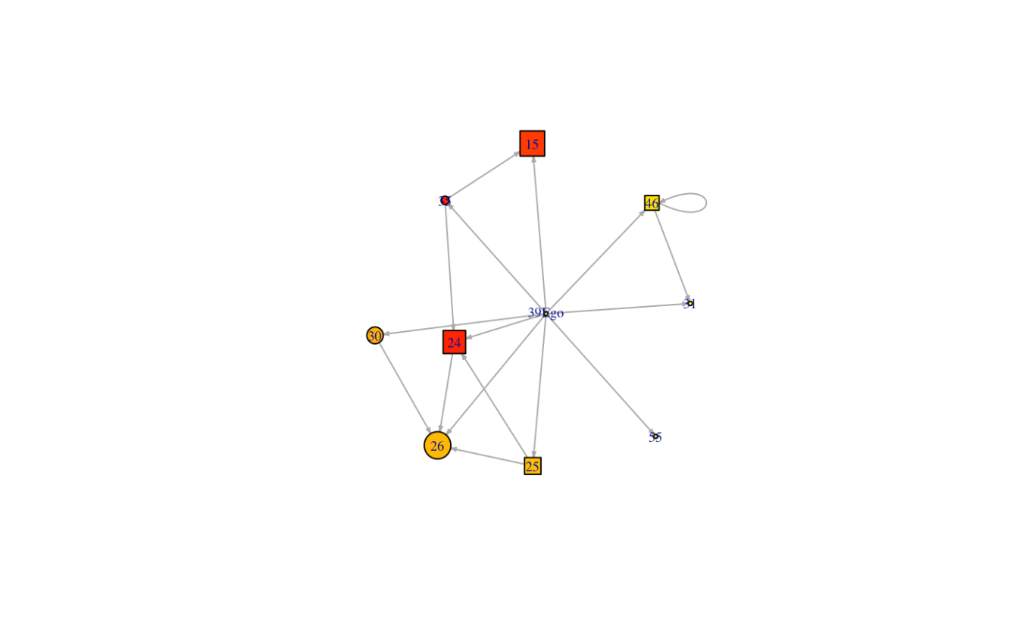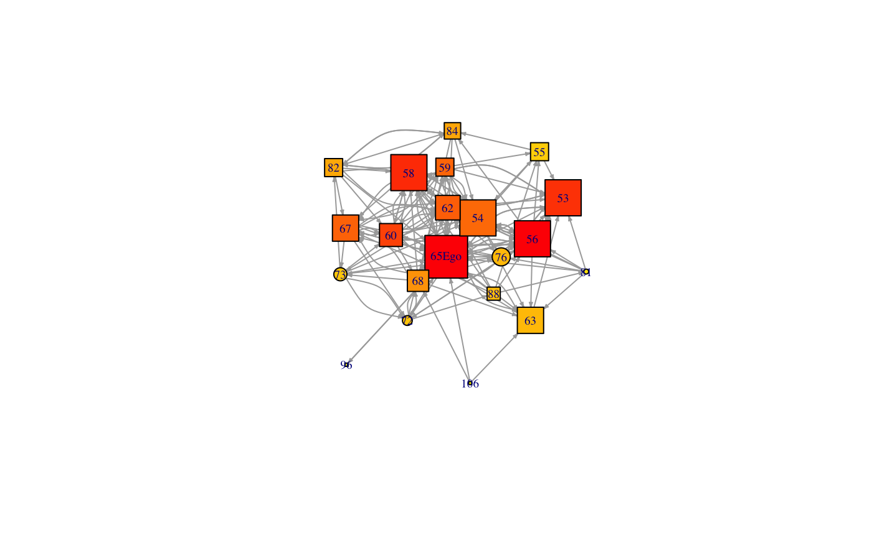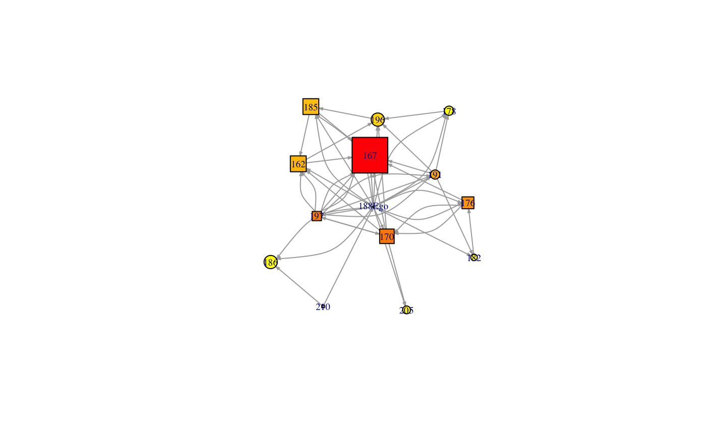

**a.39 b.65 c.188**

* Node Size: Determined by in-degree centrality, larger nodes mean greater centrality.
* Node Color: Represents eigenvector centrality. Darker shades indicate nodes with influential connections, while lighter shades represent less influential nodes.
* Node Shape**:** Represents betweenness centrality. Square nodes indicate values exceeding the median, suggesting these nodes function as vital connectors or bridges. Conversely, circular nodes fall at or below the median, indicating a lesser bridging role.

Student 65, positioned at the center of network engagement, exhibits a highly influential role. This student's node, visually larger and darker compared to others, indicates a robust level of interactions received (indegree) and strong ties with other influential participants (eigenvector centrality). Such a configuration underscores Student 65's central role in the discourse, acting as a crucial bridge across various discussion threads (high betweenness centrality). The square shape of the node further highlights this bridging role, positioning Student 65 not just as a participant but as a pivotal connector enhancing the flow of communication within the network.

In contrast, Students 39 and 188 exhibit significantly less influence and engagement. Student 39, with no recorded responses (indegree of 0) and a circular node shape, appears on the periphery of the network. This student, despite moderate activity (outdegree), fails to make impactful connections, reflected in the absence of betweenness and a very low eigenvector score. The sparse clustering around this node suggests limited integration within the group, further isolating Student 39 from the core interactions. Similarly, Student 188 shows a slightly higher level of activity compared to Student 39 but receives minimal responses, as indicated by a very low indegree. The slightly larger outdegree suggests an attempt to engage, yet this does not translate into influence or central connectivity, evidenced by low eigenvector and betweenness scores. The clustering coefficient for Student 188, while higher than that of Student 39, still indicates less dense connections, which might contribute to the minimal engagement this student receives. The subsequent table provides a detailed breakdown of individual node attributes (Table 4).

**Table 4. Normalized Ego network measures**

|  |  |  |  |  |  |  |  |  |
| --- | --- | --- | --- | --- | --- | --- | --- | --- |
| Node | Level | Course | Indegree | Outdegree | Closeness | Betweenness | Eigenvector | Clustering Coefficient |
| 65 | High | C4 | 0.5 | 0.30769 | 0.00952 | 267.22314 | 1 | 0.40526 |
| 188 | Low | C6 | 0.02 | 0.34 | 0.01031 | 11.66864 | 0.30762 | 0.28205 |
| 39 | Low | C5 | 0 | 0.18367 | 0.00943 | 0 | 0.09045 | 0.19444 |

This qualitative and quantitative portrayal of individual networks illustrate the varying degrees of connectivity and influence. It highlights how certain students, like Student 65, become central figures, facilitating and enriching the dialogue, whereas others remain largely on the fringes, struggling to impact or benefit from the network's collaborative potential. Such insights are instrumental in understanding and potentially reshaping educational strategies to foster more inclusive and effective online interactions.

**DISCUSSION**

This study first employed ANOVA to examine the network metrics of students receiving high and low responses within online discussions. The findings revealed significant differences, particularly in terms of indegree, eigenvector, and closeness centralities. Notably, indegree and eigenvector centralities exhibited the strongest effects, underscoring the evident influence these metrics have on student visibility and perceived authority within the network. Conversely, outdegree and clustering coefficient did not demonstrate significant impact, suggesting that simply increasing message output does not correlate with greater engagement, and tight-knit clusters do not necessarily enhance interaction beyond their bounds.

The regression analysis extended these insights by quantifying the relationships between various network metrics and indegree centrality. We found that outdegree negatively influences indegree, possibly indicating a potential dilution of message impact with increased output, which may reflect a focus on fulfilling course requirements rather than fostering genuine peer engagement. Meanwhile, betweenness and eigenvector centrality were positively correlated with indegree, highlighting the roles of these students as crucial connectors and influential figures within the network. However, closeness centrality did not emerge as a significant predictor, suggesting that proximity in terms of network paths does not necessarily equate to higher engagement levels. The significant role of eigenvector centrality aligns with the "rich club" phenomenon, where well-connected individuals within a network tend to form a tightly-knit group that dominates discussions. This aspect was particularly evident among students who not only received a high volume of responses but also facilitated broader dialogues across various threads, thereby enriching the discourse. Such students often bridge the communication gap between disparate groups, enhancing the richness of discussions. This bridging capability, reflected in betweenness centrality, underscores their role in enhancing information flow, making discussions more inclusive and integrated.

The ego network analysis offered detailed insights into how individual behaviors impact group dynamics within online discussions. Specifically, the analysis of students like 65 and 188 demonstrated how individuals with strong network positions can enhance the overall quality and inclusiveness of dialogue. Student 65, distinguished by high indegree and eigenvector centrality, played a crucial role in engaging less active members, effectively integrating them into the core discussions and fostering a more dynamic and inclusive community. Furthermore, these influential individuals often raise the profile of less visible participants, particularly those from the less active segments of the network. Their interactions with these quieter quarters can spotlight these members, encouraging broader participation and recognition within the group. However, this dynamic also highlighted a potential drawback observed among third quartile responders, who were tightly knit. This closeness, while fostering strong bonds within the subgroup, tended to isolate them from the wider discussion, limiting their influence and integration with the broader network. This scenario illustrates the complex nature of social interactions within educational networks, where the roles assumed by individuals can significantly affect the overall connectivity and flow of discussions. It points to the need for strategies that not only promote active engagement from central figures but also encourage integration across different network clusters to ensure a cohesive and inclusive discussion environment.

**CONCLUSION**

This study has rigorously explored the variations in network metrics between students receiving high and low responses in online discussion, identifying critical predictors of indegree and revealing the distinct roles individuals play within network dynamics. Our findings reveal that central figures within the network enhance dialogue quality as well as help integrate less active participants into the discussions, which is pivotal for maintaining a vibrant and inclusive educational environment (Haythornthwaite, 2005)

A key implication of this research is the necessity for educators to look beyond the mere volume of students' contributions, such as fulfilling basic requirements of posting quantity of student’s contribution like having requirement of ‘write one post and two replies’. Instead, emphasis should be placed on the quality and impact of these contributions within the learning community (Garrison et al., 1999; Wise & Cui, 2018). It is crucial for instructors to identify and mitigate potential communication barriers that could hinder student engagement, such as ineffective message content or presentation style. Addressing these issues can make students feel more valued and understood, thereby enriching their overall learning experience. Moreover, the integration of network analytics with caution into online learning platforms can profoundly enhance the educational landscape (Dawson et al., 2010; Marbouti & Wise., 2016; Lee & Clariana, 2024). By analyzing the depth and nature of interactions, educators can proactively identify and support students who struggle to connect with their peers, even if they are active participants (De Laat & Prinsen, 2014). This approach not only fosters inclusion but also enhances the educational outcomes by ensuring all students are effectively engaged.

Despite these valuable insights, this study has several limitations. First, the analysis relied solely on interaction data, without incorporating demographic, cognitive, or affective factors that could influence engagement patterns. Such variables might offer a more comprehensive understanding of why certain students are more central to discussions than others. Second, the data was collected from a single online course, limiting the generalizability of the findings to other contexts or courses. The specific characteristics of the course, including its structure and discussion prompts, may have influenced the interaction dynamics observed. Lastly, while the study focused on network metrics to understand engagement, the content and context of individual posts were not analyzed in depth, which could have provided further insights into why certain contributions attract more responses.

Building on these insights, future research should focus on a detailed discourse analysis of the contributions made by students who are active yet receive limited responses. This analysis will help uncover the qualitative aspects of communication that affect student engagement and resonance within the community. Investigating these aspects can provide a deeper understanding of how certain content characteristics influence the interaction dynamics. Additionally, there is a significant opportunity for longitudinal studies to examine how changes in network metrics over time correspond to shifts in student engagement and performance. Such studies could explore the causal relationships between a student's network position and their learning outcomes, offering valuable insights for designing more targeted and impactful educational interventions.

By combining quantitative and qualitative network analyses, this study contributes to a more nuanced understanding of the social dimensions of online learning. It highlights the intricate factors that influence student engagement and underscores the potential of network analysis to enhance educational strategies in digital settings. This comprehensive approach sheds light on the current dynamics of online learning communities and sets the stage for future advancements in educational technology and pedagogy. This study comprehensively explored the significant differences in network metrics between high and low response receivers in online discussion, identifying key predictors of indegree, and highlighting the influence and roles of specific individuals within the network dynamics.

**References**

Bakharia, A., & Dawson, S. (2011, February). SNAPP: a bird's-eye view of temporal participant interaction. In Proceedings of the 1st international conference on learning analytics and knowledge (pp. 168-173).

Baldwin, T. T., Bedell, M. D., & Johnson, J. L. (1997). The social fabric of a team-based M.B.A. program: Network effects on student satisfaction and performance. *Academy of Management Journal, 40*(6), 1369–1397. [https://doi.org/10.2307/257037](https://psycnet.apa.org/doi/10.2307/257037)

Boling, E. C., Hough, M., Krinsky, H., Saleem, H., & Stevens, M. (2012). Cutting the distance in distance education: Perspectives on what promotes positive, online learning experiences. The Internet and Higher Education, 15(2), 118-126.

Borgatti, S. P., Jones, C., & Everett, M. G. (1998). Network measures of social capital. Connections, 21(2), 27-36.

Borup, J., West, R. E., & Graham, C. R. (2012). Improving online social presence through asynchronous video. The Internet and Higher Education, 15(3), 195-203.

Carvalho, L., Goodyear, P., & de Laat, M. (Eds.). (2016). Place-based spaces for networked learning. Routledge.

Dawson, S. (2010). ‘Seeing’ the learning community: An exploration of the development of a resource for monitoring online student networking. British Journal of Educational Technology, 41(5), 736-752.

De Laat, M. (2012). Enabling professional development networks: How connected are you?. Open Universteit.

De Laat, M., & Prinsen, F. (2014). Social Learning Analytics: Navigating the Changing Settings of Higher Education. Journal of Research & Practice in Assessment, 9, 51-60. [http://www.rpajournal.com/social-learning- analytics-navigating-the-changing-settings-of-higher-education/](http://www.rpajournal.com/social-learning-%20analytics-navigating-the-changing-settings-of-higher-education/)

Dennen, V. P. (2008). Looking for evidence of learning: Assessment and analysis methods for online discourse. Computers in Human Behavior, 24(2), 205-219. <https://doi.org/10.1016/j.chb.2007.01.010>

Dixson, M. D. (2015). Measuring student engagement in the online course: The Online Student Engagement scale (OSE). Online Learning, 19(4), 143–157. <https://doi.org/10.24059/olj.v19i4.561>

Dringus, L. P., & Ellis, T. (2010). Temporal transitions in participation flow in an asynchronous discussion forum. Computers & Education, 54(2), 340-349.

Galikyan, I., & Admiraal, W. (2019). Students' engagement in asynchronous online discussion: The relationship between cognitive presence, learner prominence, and academic performance. The Internet and Higher Education, 43, 100692.

Gao, F., Zhang, T., and Franklin, T. 2013. Designing asynchronous online discussion environments: Recent progress and possible future directions. British Journal of Educational Technology. 44, 3, 469–483. <https://doi.org/10.1111/j.1467-8535.2012.01330.x>

Garrison, D. R., Anderson, T., & Archer, W. (1999). Critical inquiry in a text-based environment: Computer conferencing in higher education. The Internet and Higher Education, 2(2-3), 87-105.

Gros, B., & García-Peñalvo, F. J. (2023). Future trends in the design strategies and technological affordances of e-learning. In Learning, design, and technology: An international compendium of theory, research, practice, and policy (pp. 345-367). Cham: Springer International Publishing.

Haythornthwaite, C. (2000). Online personal networks: Size, composition and media use among distance learners. New Media & Society, 2(2), 195-226.

Haythornthwaite, C. (2005). Social networks and Internet connectivity effects. Information, Communication & Society, 8(2), 125-147.

Haythornthwaite, C., & De Laat, M. (2010, May). Social networks and learning networks: Using social network perspectives to understand social learning. In Proceedings of the 7th international conference on networked learning (pp. 183-190). Aalborg, Denmark: Lancaster University.

Hew, K. F., & Cheung, W. S. (2011). Higher-level knowledge construction in asynchronous online discussions: An analysis of group size, duration of online discussion, and student facilitation techniques. Instructional Science, 39, 303-319.

Hrastinski, S. (2008). Asynchronous and synchronous e-learning. Educause Quarterly, 31(4), 51-55.

Kaliisa, R., Rienties, B., Mørch, A. I., & Kluge, A. (2022). Social learning analytics in computer-supported collaborative learning environments: A systematic review of empirical studies. Computers and Education Open, 3, 100073.

Koh, J. H. L., Herring, S. C., & Hew, K. F. (2010). Project-based learning and student knowledge construction during asynchronous online discussion. The Internet and Higher Education, 13(4), 284-291. <https://doi.org/10.1016/j.iheduc.2010.09.003>

Kovanović, V., Gašević, D., Joksimović, S., Hatala, M., & Adesope, O. (2015). Analytics of communities of inquiry: Effects of learning technology use on cognitive presence in asynchronous online discussions. The Internet and Higher Education, 27, 74-89. <https://doi.org/10.1016/j.iheduc.2015.06.002>

Lee, M.K., Roy B. Clariana (2024, April). Implementing sociograms in online learning: examining their influences on community of inquiry elements, accepted as a poster, AERA, Philadelphia. 10.3102/2107692.

Marbouti, F., & Wise, A. F. (2016). Starburst: A new graphical interface to support purposeful attention to others' posts in online discussions. Educational Technology Research and Development, 64(1), 89-111.

Palonen, T., & Hakkarainen, K. (2013, April). Patterns of interaction in computer-supported learning: A social network analysis. In International Conference of the Learning Sciences (pp. 334-339). Psychology Press.

Romero, C., López, M. I., Luna, J. M., & Ventura, S. (2013). Predicting students' final performance from participation in on-line discussion forums. Computers & Education, 68, 458-472.

Rosé, C. P., & Ferschke, O. (2016). Technology support for discussion based learning: From computer supported collaborative learning to the future of massive open online courses. International Journal of Artificial Intelligence in Education, 26, 660-678.

Russo, T. C., & Koesten, J. (2005). Prestige, centrality, and learning: A social network analysis of an online class. Communication Education, 54(3), 254-261.

Saqr, M., & Alamro, A. (2019). The role of social network analysis as a learning analytics tool in online problem-based learning. BMC Medical Education, 19(1), 1-11. DOI: 10.1186/s12909-019-1521-1

Saqr, M., Fors, U., & Tedre, M. (2020a). How learning analytics can early predict under-achieving students in a blended medical education course. BMC Medical Education, 20(1), 1-11. <https://doi.org/10.1186/s12909-020-1972-9>

Saqr, M., Nouri, J., Vartiainen, H., & Tedre, M. (2020b). Robustness and rich clubs in collaborative learning groups: A learning analytics study using network science. Scientific Reports, 10(1), 14445.

Saqr, M., & López-Pernas, S. (2021). The longitudinal trajectories of online engagement over a full program. Computers & Education, 175, Article 104325. <https://doi.org/10.1016/j.compedu.2021.104325>

Saqr, M., Elmoazen, R., Tedre, M., López-Pernas, S., & Hirsto, L. (2022). How well centrality measures capture student achievement in computer-supported collaborative learning?–A systematic review and meta-analysis. Educational Research Review, 35, 100437.

Shum, S. B., & Ferguson, R. (2012). Social learning analytics. Journal of educational technology & society, 15(3), 3-26.

Siemens, G. (2013). Learning analytics: The emergence of a discipline. American Behavioral Scientist, 57(10), 1380-1400. <https://doi.org/10.1177/0002764213498851>

Simpson, O. (2013). Supporting students for success in online and distance education. Routledge.

Tinto, V. (1998). Colleges as communities: Taking research on student persistence seriously. The Review of Higher Education, 21(2), 167–177. <https://doi.org/10.1353/rhe.1998.0024>

Vlachopoulos, P. (2012, November). The importance of power dynamics in the development of asynchronous online learning communities. In Proceedings of ASCILITE-Australian Society for Computers in Learning in Tertiary Education Annual Conference.

Wise, A. F., Perera, N., Hsiao, Y.-T., Speer, J., & Marbouti, F. (2012). Microanalytic case studies of individual participation patterns in an asynchronous online discussion in an undergraduate blended course. The Internet and Higher Education, 15(2), 108-117.

Wise, A. F., Zhao, Y., & Hausknecht, S. (2014). Learning analytics for online discussions: Embedded and <https://doi.org/10.18608/jla.2014.12.4>

Wise, A. F., & Cui, Y. (2018). Unpacking the relationship between discussion forum participation and learning in MOOCs: Content is key. ACM International Conference Proceeding Series, 330–339. <https://doi.org/10.1145/3170358.3170403>

Yang, C. C., Flanagan, B., Akçapınar, G., and Ogata, H. 2019. Investigating subpopulation of students in digital textbook reading logs by clustering. In Companion Proceedings of the 9th International Conference on Learning Analytics and Knowledge (LAK'19). Society for Learning Analytics Research (SoLAR), 465-470.

Xie, J., & Correia, A.-P. (2023). The effects of instructor participation in asynchronous online discussions on student performance: A systematic review. British Journal of Educational Technology, 00, 1–19. <https://doi.org/10.1111/bjet.13350>